RAJAGIRI SCHOOL OF ENGINEERING & TECHNOLOGY

RAJAGIRI VALLEY, KAKKANAD, KOCHI- 682 039

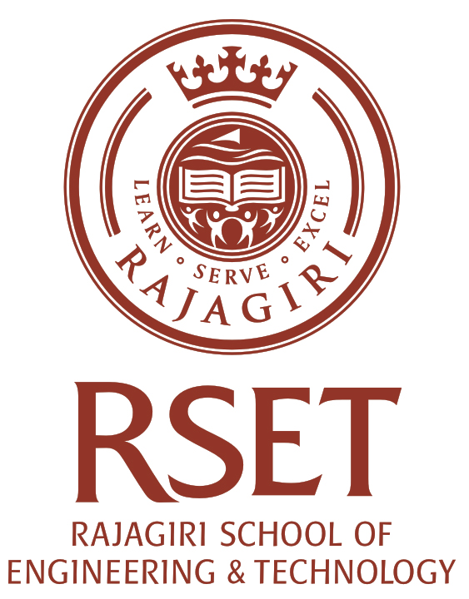

CERTIFICATE

Certified that this is a Bonafide Record of the Mini project on Smart Personal Manager done by Group 4 of branch Computer Science and Engineering during the Semester Eight, Year 2010 at Rajagiri School of Engineering and Technology, Kakkanad, Kochi.

Project Guide

Staff in Charge Head of the Department

Submitted for the practical examination conducted on………………

Internal Examiner External Examiner

